SMS SPAM DETECTION USING DEEP LEARNING
A Final-Year Project Report

Submitted in partial fulfilment of the requirements for the award of
[B-tech CS DS+AI]

Submitted by
[Abhishek , Akshay Pratap Singh , Shashwat Shukla ] | [72,64,116]

Under the guidance of
[Mr. Raghav Sharma]

[Computer Science]
[Shri Ramswaroop Memorial University]
[2026-2027]

Declaration
I declare that this project report, titled “SMS Spam Detection Using Deep Learning,” is prepared for academic submission and describes the implementation and experimental evidence available for this project. Any institutional declaration wording, originality statement, signature, and date should be completed according to the college's prescribed format.

Acknowledgement
I would like to express my gratitude to my project supervisor, department, and institution for their guidance and support. I also acknowledge the maintainers of the SMS Spam Collection dataset and the developers of the open-source Python libraries used in this project.

Abstract
SMS spam is an unwanted-message problem in which promotional, deceptive, or fraudulent messages compete with legitimate personal communication. This project develops a text-classification system that categorizes SMS messages as normal (ham) or spam. The available workflow uses Python-based data inspection and exploratory analysis, a Bidirectional Long Short-Term Memory (BiLSTM) model implemented with Keras, and a Streamlit interface for interactive predictions. A TF-IDF feature representation with Logistic Regression is also evaluated as a traditional machine-learning baseline. The uploaded exploratory summary reports 5,572 labelled messages: 4,825 ham (86.59%) and 747 spam (13.41%). On a reported test set of 1,032 messages, the BiLSTM confusion matrix records 892 true negatives, 12 false positives, 8 false negatives, and 120 true positives. These counts correspond to 98.06% accuracy, 90.91% spam precision, 93.75% spam recall, and 92.31% spam F1-score. The baseline confusion matrix records 891 true negatives, 13 false positives, 8 false negatives, and 120 true positives, corresponding to 97.97% accuracy and 91.95% spam F1-score. The results indicate a small advantage for the BiLSTM on these reported outputs. The report distinguishes directly supplied data from metrics calculated from confusion matrices and notes that conclusions depend on the dataset, split, preprocessing, and evaluation protocol.

Keywords
SMS spam detection; text classification; Natural Language Processing; BiLSTM; TF-IDF; Logistic Regression; confusion matrix; Streamlit.

Table of Contents
- Chapter 1 — Introduction
- Chapter 2 — Literature Review and Existing Approaches
- Chapter 3 — Requirements and System Analysis
- Chapter 4 — Dataset and Exploratory Data Analysis
- Chapter 5 — Methodology and Model Design
- Chapter 6 — Implementation
- Chapter 7 — Results and Discussion
- Chapter 8 — Conclusion and Future Scope
- References
- Appendix A — Viva Questions and Answers
- Appendix B — Reproducibility and Submission Checklist

Chapter 1 — Introduction

1.1 Background
Short Message Service (SMS) remains a convenient channel for personal, commercial, and service-related communication. However, unsolicited messages may advertise products, impersonate organizations, or attempt to persuade recipients to disclose information or take unwanted actions. A spam detector can support users by identifying messages whose language resembles known spam examples.

1.2 Problem Statement
The task is to classify a message into one of two categories: ham (legitimate or normal) and spam (unwanted or suspicious according to the dataset label). The challenge is to learn useful language patterns from labelled text while avoiding both false alarms on legitimate messages and missed spam.

1.3 Aim
To develop and evaluate an SMS text-classification application using a deep learning model and compare its results with a traditional machine-learning baseline.

1.4 Objectives
- Inspect and validate the labelled SMS dataset.
- Explore class balance and message-length characteristics.
- Prepare training and test data for supervised classification.
- Train a BiLSTM-based deep learning classifier.
- Train a TF-IDF + Logistic Regression baseline.
- Evaluate predictions using accuracy, spam precision, spam recall, F1-score, and confusion matrices.
- Provide an interactive interface for entering messages and viewing predictions.
- Document observed results, limitations, and future improvements.

1.5 Scope
The current scope is binary classification of English-language SMS examples represented in the supplied dataset. The interface supports user-entered text and presents the model's output. The system is an educational prototype; it does not verify sender identity, inspect carrier metadata, or guarantee that a message is safe.

1.6 Significance
The project demonstrates a complete applied machine-learning workflow: data inspection, exploratory analysis, supervised model training, quantitative evaluation, model comparison, saving trained artifacts, and deployment through a lightweight web interface.

Chapter 2 — Literature Review and Existing Approaches

2.1 Rule-Based Filtering
Rule-based filters flag messages using manually specified words, patterns, or sender rules. They are simple to interpret, but they may fail when spam wording changes and can incorrectly flag legitimate messages that contain suspicious terms.

2.2 Traditional Machine Learning
Traditional text classifiers convert messages into numerical features. TF-IDF weights terms according to their usefulness in distinguishing documents, while Logistic Regression estimates a class probability from the feature vector. This combination is a practical baseline because it is relatively efficient and provides a useful point of comparison.

2.3 Deep Learning for Text
Neural text classifiers can learn representations from token sequences. Long Short-Term Memory (LSTM) networks were designed to model sequential dependencies; a bidirectional LSTM processes a sequence in both directions. In a text-classification setting, this can provide contextual features from earlier and later tokens, subject to the model's vocabulary, sequence length, training data, and architecture.

2.4 Evaluation Considerations
Accuracy alone can be misleading when classes are imbalanced. Precision measures the fraction of predicted spam that is truly spam, recall measures the fraction of actual spam detected, and F1-score is the harmonic mean of precision and recall. A confusion matrix exposes false positives and false negatives directly.

2.5 Position of This Project
The project evaluates a BiLSTM model alongside a TF-IDF + Logistic Regression baseline. This comparison is useful because it tests whether the additional complexity of a neural sequence model produces a measurable improvement on the supplied evaluation results. The available results show a small difference; they do not establish universal superiority.

Chapter 3 — Requirements and System Analysis

3.1 Functional Requirements
- The project shall load labelled SMS data for analysis and training.
- The project shall inspect labels and summarize dataset characteristics.
- The project shall train a deep-learning classifier and save its model artifact.
- The project shall evaluate predictions with classification metrics and a confusion matrix.
- The project shall train a traditional baseline and save its results.
- The web interface shall accept a text message and display a predicted category.

3.2 Non-Functional Requirements
- Reproducibility: scripts and dependency versions should be recorded.
- Usability: the prediction interface should be simple to operate.
- Maintainability: data preparation, training, evaluation, and UI code should be separated where practical.
- Transparency: evaluation outputs should be reported honestly, including errors and limitations.

3.3 Software and Hardware
Component | Project evidence / requirement
Programming language | Python (installed in the user's environment)
IDE | PyCharm
Deep learning | TensorFlow / Keras
Traditional ML and metrics | scikit-learn
Data analysis | Pandas; plotting with Matplotlib
User interface | Streamlit
Model artifacts | sms_spam_bilstm.keras and tfidf_logistic_regression.joblib (baseline artifact name from implementation)
Hardware | A standard personal computer capable of running Python; exact CPU, RAM, and OS specifications were not supplied

3.4 System Architecture
The logical flow is: labelled SMS dataset → inspection and exploratory analysis → train/test preparation → text representation and model training → saved model artifact → evaluation reports → Streamlit prediction interface. The BiLSTM branch uses a sequence/token representation configured in the training script. The baseline branch uses TF-IDF features followed by Logistic Regression. The exact tokenization, vocabulary size, padding length, epoch count, and UI loading implementation should be confirmed against the final source code before submission.

3.5 Feasibility
Technical feasibility is supported by the successful execution of the project scripts and the existence of a saved BiLSTM model, report images, and baseline evaluation output. The project uses widely available Python tooling. The current prototype is appropriate for demonstration and academic evaluation, although production deployment would require additional testing, privacy review, monitoring, and security controls.

Chapter 4 — Dataset and Exploratory Data Analysis

4.1 Dataset Description
The uploaded EDA summary reports 5,572 rows after label validation and zero rows excluded for invalid labels. The class counts are 4,825 ham messages (86.59%) and 747 spam messages (13.41%). The summary also records 403 duplicate rows before any removal. This duplicate count is a pre-removal statistic; the uploaded summary alone does not establish whether duplicates were removed before the final train/test split.

4.2 Class Distribution
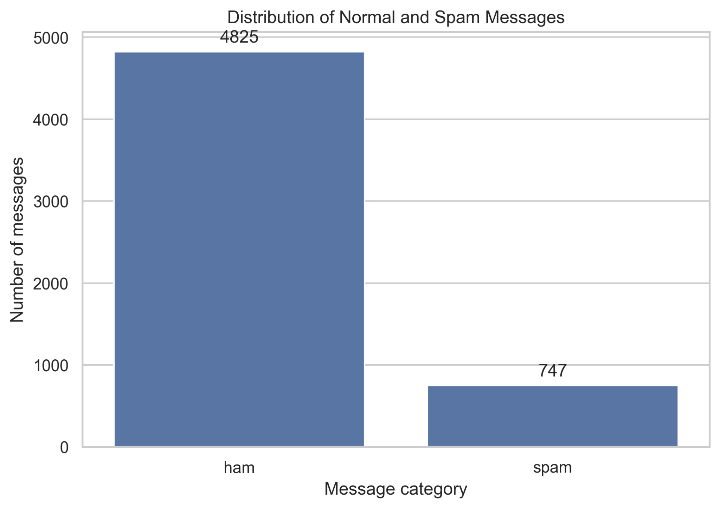
Figure 4.1. Class distribution of normal and spam messages. The dataset is imbalanced: ham messages form approximately 86.59% of the labelled rows, while spam forms approximately 13.41%. Consequently, evaluation should include spam precision, recall, F1-score, and the confusion matrix in addition to accuracy.

4.3 Message Length
Label | Mean characters | Median characters | Mean words | Median words | Character range
Ham | 71.56 | 52 | 14.31 | 11 | 2–910
Spam | 139.12 | 149 | 23.91 | 25 | 13–224
According to the EDA summary, spam messages are longer on average than ham messages in this dataset. These are descriptive statistics rather than a rule for classification: message length alone cannot reliably determine whether an individual message is spam.
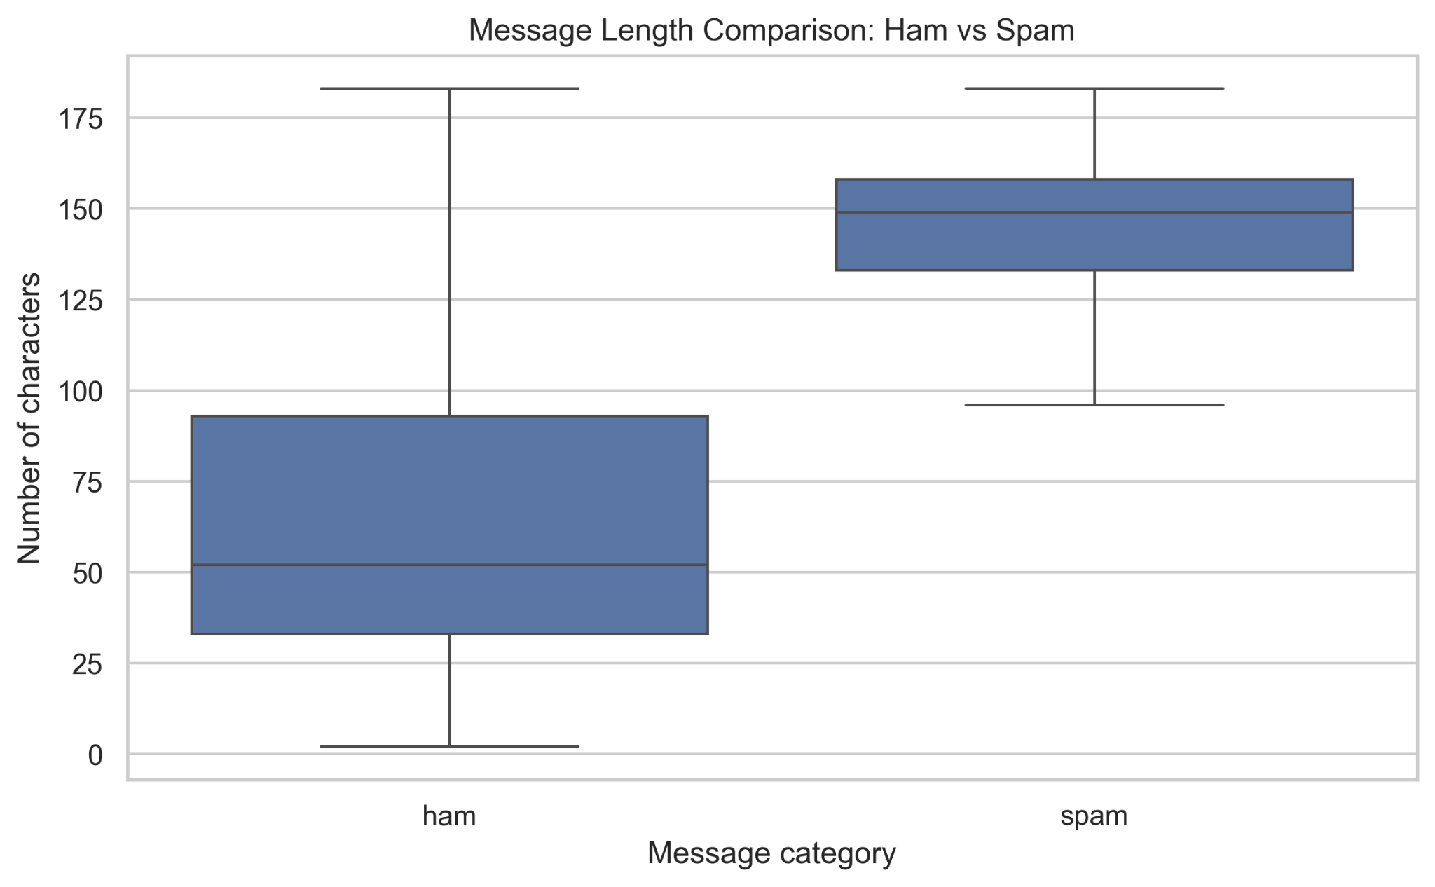
Figure 4.2. Message-length comparison by label. The boxplot suggests a higher median character count for spam messages than for ham messages.
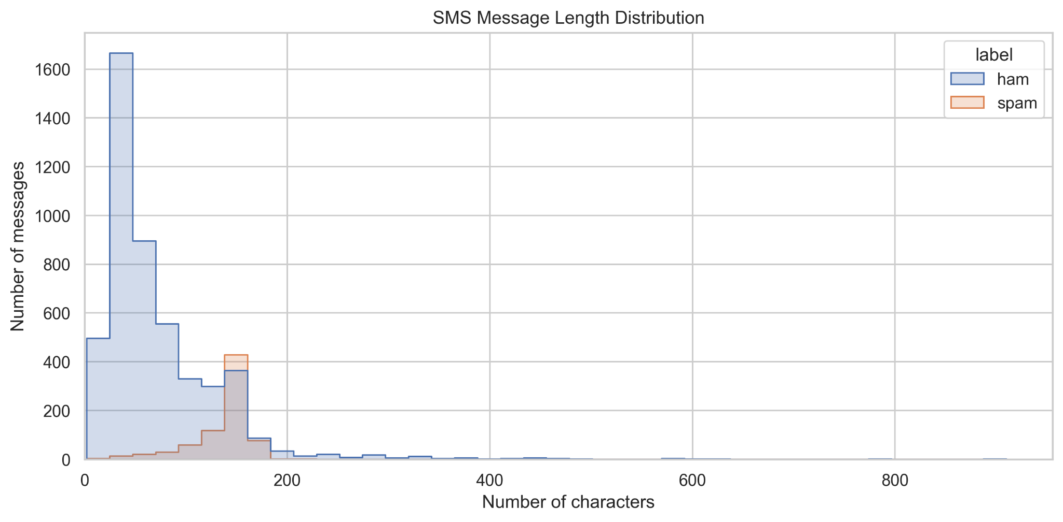
Figure 4.3. Distribution of message lengths. The plot shows that many ham messages are short, while spam examples are more concentrated at longer lengths; the distributions still overlap.

4.4 Data Quality and Leakage Considerations
The EDA summary records 403 duplicate rows before removal. Duplicate handling matters because identical or near-identical messages appearing in both training and test data can inflate apparent performance. For a rigorous final experiment, document whether duplicates were removed and ensure the test set is not used during model fitting or tuning. The exact preprocessing steps must be verified from the source scripts.

4.5 Dataset Source
The project README identifies the UCI SMS Spam Collection as the dataset source. The official dataset page is listed in the references. Confirm the downloaded archive and any redistribution conditions before including the raw data in a submission package.

Chapter 5 — Methodology and Model Design

5.1 Overall Workflow
- Load and inspect the dataset.
- Validate labels and examine missing values, duplicates, class counts, and message lengths.
- Prepare a training set and a held-out test set.
- Train the BiLSTM model using the text-sequence representation implemented in the project.
- Train the TF-IDF + Logistic Regression baseline on the training data.
- Generate predictions on the held-out test data.
- Calculate evaluation metrics and create confusion matrices.
- Save model artifacts and reports.
- Load the trained model in the web interface and test example messages.

5.2 Text Classification Labels
The target categories are ham and spam. For the uploaded confusion matrices, ham is the first row/column and spam is the second. Therefore, the top-left cell is correctly predicted ham, the top-right cell is ham incorrectly predicted as spam, the bottom-left cell is spam incorrectly predicted as ham, and the bottom-right cell is correctly predicted spam.

5.3 Bidirectional LSTM
An LSTM is a recurrent neural network architecture that uses gated state updates to retain useful information over a sequence. A bidirectional layer processes token sequences in forward and reverse directions and combines the resulting representations. A classifier head then maps the learned representation to the ham/spam output. The saved project artifact is named sms_spam_bilstm.keras. The precise layer dimensions, embedding size, dropout settings, sequence length, optimizer, loss function, and training epochs must be transcribed from src/train_model.py for a fully implementation-specific report; they are not inferred here.

5.4 TF-IDF + Logistic Regression Baseline
The baseline uses Term Frequency–Inverse Document Frequency (TF-IDF) features with Logistic Regression. The supplied baseline script configuration uses lowercase text, Unicode accent stripping, unigrams and bigrams, a maximum of 20,000 features, sublinear term-frequency scaling, class_weight='balanced', and max_iter=2000. TF-IDF converts text into weighted numerical features, and Logistic Regression learns a decision boundary between the two labels.

5.5 Evaluation Metrics
Let TP denote spam correctly identified as spam, TN denote ham correctly identified as ham, FP denote ham incorrectly labelled spam, and FN denote spam incorrectly labelled ham.
- Accuracy = (TP + TN) / (TP + TN + FP + FN).
- Spam precision = TP / (TP + FP).
- Spam recall = TP / (TP + FN).
- Spam F1-score = 2 × precision × recall / (precision + recall).
For this report, spam is treated as the positive class when calculating spam precision, recall, and F1-score. Values calculated from a confusion matrix can differ slightly from a metrics file that stores rounded values.

Chapter 6 — Implementation

6.1 Development Environment
Development was carried out in PyCharm using a Python virtual environment. The user reports that Python, PyCharm, dependencies, data inspection, model training, and the web application are working. The project includes data, models, reports, and source-code directories.

6.2 Data Inspection and EDA
The inspection and EDA scripts check the input data and generate summary statistics and visualizations. Available outputs include the class-distribution chart, message-length distribution, message-length comparison, EDA summary text/CSV, and confusion matrices.

6.3 Model Training and Artifacts
The trained BiLSTM is stored as models/sms_spam_bilstm.keras. The baseline evaluation output reports TF-IDF + Logistic Regression results and a baseline confusion matrix. The supplied baseline implementation also saves the fitted pipeline as models/tfidf_logistic_regression.joblib and writes evaluation artifacts into reports.

6.4 Web Application
The Streamlit interface accepts a user-entered SMS message and displays the model's predicted category and a score. The application should be tested with both normal and spam examples. Any displayed probability or score should be described as a model output, not a guarantee that a message is safe or malicious.

6.5 Reproducibility
The project includes requirements.txt and README.md according to the user's completion checklist. For a clean handover, keep the dependency file aligned with the active environment and confirm that the README commands match the actual script filenames and paths. Store results with the code version and record random seeds and split details from the training script.

Chapter 7 — Results and Discussion

7.1 Test-Set Results
The baseline_results.txt file reports 1,032 test samples. The baseline confusion matrix is [[891, 13], [8, 120]]. The supplied BiLSTM confusion matrix is [[892, 12], [8, 120]]. Each matrix sums to 1,032 examples and has 904 ham examples and 128 spam examples.
Metric (spam positive class) | BiLSTM (from matrix) | TF-IDF + Logistic Regression
Test samples | 1,032 | 1,032
Accuracy | 98.06% | 97.97%
Spam precision | 90.91% | 90.23%
Spam recall | 93.75% | 93.75%
Spam F1-score | 92.31% | 91.95%
True negatives (TN) | 892 | 891
False positives (FP) | 12 | 13
False negatives (FN) | 8 | 8
True positives (TP) | 120 | 120
Note: the Logistic Regression metrics above are recalculated from the uploaded confusion matrix to keep both model columns methodologically comparable. The supplied baseline_results.txt separately reports accuracy 97.97%, precision 90.23%, recall 93.75%, and F1-score 91.95%, which are consistent to rounding.

7.2 BiLSTM Confusion Matrix
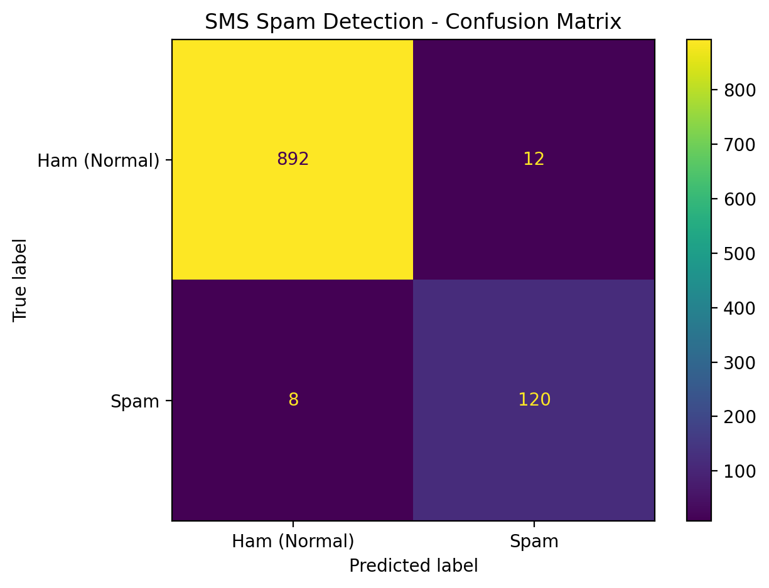
Figure 7.1. BiLSTM confusion matrix. The model correctly classifies 892 ham messages and 120 spam messages. It incorrectly flags 12 ham messages as spam and misses 8 spam messages. Thus, it correctly classifies 1,012 out of 1,032 messages.

7.3 Baseline Confusion Matrix
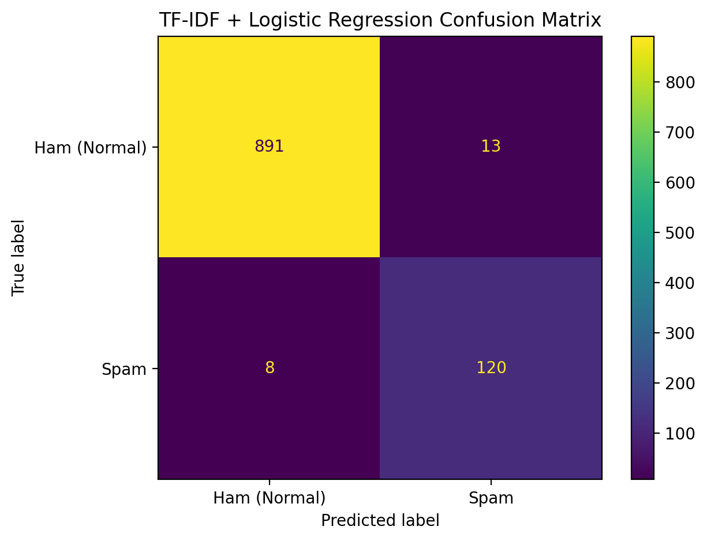
Figure 7.2. TF-IDF + Logistic Regression confusion matrix. The baseline correctly classifies 891 ham messages and 120 spam messages. It incorrectly flags 13 ham messages as spam and misses 8 spam messages.

7.4 Interpretation
- The BiLSTM accuracy calculated from its matrix is 98.06%, compared with 97.97% for the baseline: a difference of about 0.10 percentage points.
- The BiLSTM has one fewer false positive in the supplied matrix (12 versus 13). Both matrices contain eight false negatives.
- The spam recall is 93.75% for both models because each identifies 120 of 128 spam messages.
- The spam F1-score calculated from the matrices is approximately 92.31% for the BiLSTM and 91.95% for the baseline.
- The observed advantage is small. It should be reported as an outcome on this test set, not as proof that BiLSTM is inherently superior.

7.5 Limitations of the Evidence
The uploaded files do not include a saved BiLSTM classification report with all metrics, the complete training configuration, or enough information to independently verify the exact data-splitting and duplicate-removal procedure. The BiLSTM metrics in this chapter are therefore calculated from the supplied matrix. A stronger comparison should ensure both models use exactly the same held-out examples and that no duplicates or related messages leak across the split. A single test set also does not measure performance on new, modern, multilingual, or adversarial spam.

7.6 Acceptance Testing
Test | Expected behaviour | Status evidence
Launch Streamlit app | Application opens locally | User reports application runs
Enter a normal SMS | Prediction is displayed | Manual test should be recorded by user
Enter a spam-like SMS | Prediction is displayed | Manual test should be recorded by user
Load saved BiLSTM | Model loads without error | User reports model/app runs
Generate baseline report | Metrics and confusion matrix saved | Uploaded baseline results and matrix
Generate EDA figures | Charts and summary generated | Uploaded EDA figures and summary

Chapter 8 — Conclusion and Future Scope

8.1 Conclusion
This project implements an SMS spam classification workflow using a BiLSTM deep learning model and a TF-IDF + Logistic Regression baseline. The supplied EDA summary contains 5,572 labelled messages and shows a substantial class imbalance, with ham messages outnumbering spam messages. On the supplied 1,032-example test outputs, the BiLSTM confusion matrix corresponds to 98.06% accuracy, 90.91% spam precision, 93.75% spam recall, and 92.31% spam F1-score. The baseline confusion matrix corresponds to 97.97% accuracy and 91.95% spam F1-score. Both models identify 120 of 128 spam messages and miss eight. The BiLSTM has one fewer false positive in the provided results. Overall, both methods perform well on this test set, and the measured difference is modest.

8.2 Limitations
- The dataset reflects its collection period and may not represent current spam patterns.
- The classes are imbalanced, which makes accuracy alone insufficient.
- Duplicate rows were observed before any removal; split integrity should be verified.
- Messages in languages or styles not represented in training may be classified poorly.
- The output is a prediction, not a sender verification or a security guarantee.
- The exact BiLSTM architecture and data split should be documented from source code before final submission.

8.3 Future Scope
- Evaluate on a separate, newer SMS dataset and on messages in multiple languages.
- Use duplicate-aware splitting and, where appropriate, group similar messages to reduce leakage risk.
- Conduct repeated runs or cross-validation and report variation across runs.
- Compare BiLSTM with Naive Bayes, Linear SVM, and transformer-based models.
- Calibrate prediction probabilities and select decision thresholds based on false-positive and false-negative costs.
- Add privacy-conscious logging, clear warnings, and accessible UI design.
- Monitor model drift and retrain using appropriately labelled, consented data.

References
[1] UCI Machine Learning Repository, “SMS Spam Collection,” https://archive.ics.uci.edu/dataset/228/sms+spam+collection (accessed 11 October 2026).
[2] S. Hochreiter and J. Schmidhuber, “Long Short-Term Memory,” Neural Computation, vol. 9, no. 8, pp. 1735–1780, 1997. DOI: 10.1162/neco.1997.9.8.1735.
[3] scikit-learn developers, “TfidfVectorizer,” scikit-learn documentation, https://scikit-learn.org/stable/modules/generated/sklearn.feature_extraction.text.TfidfVectorizer.html.
[4] scikit-learn developers, “LogisticRegression,” scikit-learn documentation, https://scikit-learn.org/stable/modules/generated/sklearn.linear_model.LogisticRegression.html.
[5] TensorFlow, “tf.keras.layers.Bidirectional,” TensorFlow API documentation, https://www.tensorflow.org/api_docs/python/tf/keras/layers/Bidirectional.
[6] TensorFlow, “tf.keras.layers.LSTM,” TensorFlow API documentation, https://www.tensorflow.org/api_docs/python/tf/keras/layers/LSTM.
[7] Streamlit, “Streamlit documentation,” https://docs.streamlit.io/.

Appendix A — Viva Questions and Answers

1. What is SMS spam detection?
It is a binary text-classification task that predicts whether a message is normal (ham) or spam.

2. What dataset did you use?
The project README identifies the UCI SMS Spam Collection. The supplied EDA summary reports 5,572 labelled messages.

3. What is ham?
Ham is the dataset label for a normal or legitimate message.

4. Why is the dataset imbalanced?
There are 4,825 ham messages and 747 spam messages, so the normal class is much more common.

5. What is a BiLSTM?
A bidirectional Long Short-Term Memory network processes a token sequence in forward and reverse directions to learn sequence representations.

6. Why compare Logistic Regression?
It provides a simpler, efficient baseline to assess whether the deep learning model offers a measurable improvement.

7. What is TF-IDF?
It represents text using term-frequency information adjusted by inverse document frequency so terms more informative within the corpus can receive higher weights.

8. What is a confusion matrix?
It counts correct and incorrect predictions for each true class, exposing false positives and false negatives.

9. What is precision?
For spam as the positive class, precision is the proportion of predicted spam messages that are actually spam.

10. What is recall?
Spam recall is the proportion of all actual spam messages that the model successfully identifies.

11. Why use F1-score?
It combines precision and recall through their harmonic mean, which is useful when both types of error matter.

12. What is a false positive here?
A legitimate ham message incorrectly predicted as spam.

13. What is a false negative here?
A spam message incorrectly predicted as normal ham.

14. What were the BiLSTM results?
From the supplied confusion matrix: 892 TN, 12 FP, 8 FN, 120 TP; accuracy 98.06%, spam precision 90.91%, recall 93.75%, and F1-score 92.31%.

15. Which model performed better?
The BiLSTM matrix gives slightly higher accuracy and spam F1-score on the supplied test results. The difference is small and should not be generalized beyond this evaluation.

16. Why not report accuracy alone?
The class distribution is imbalanced, and accuracy does not show whether spam was missed or legitimate messages were incorrectly flagged.

17. What is overfitting?
Overfitting occurs when a model learns training-specific patterns that do not generalize well to unseen examples.

18. What is data leakage?
It occurs when information from the test set or related examples improperly influences model training or selection, making evaluation overly optimistic.

19. What does Streamlit do?
It provides the project's interactive web interface for entering a message and viewing a prediction.

20. What are the main limitations?
The dataset may not represent current spam, classes are imbalanced, duplicate handling needs verification, and the model cannot guarantee message safety.

Appendix B — Reproducibility and Submission Checklist
- Replace all bracketed cover-page fields with the actual student, supervisor, programme, department, college, and academic year.
- Verify that the final source code filenames and README commands match the project folder.
- Confirm the BiLSTM train/test split, preprocessing, architecture, epoch count, random seed, and model-selection procedure from src/train_model.py.
- Confirm duplicate handling and ensure train/test separation prevents leakage.
- Keep the original evaluation output files and record which confusion matrix belongs to which model.
- Include screenshots of the running Streamlit app and successful normal/spam test cases if required by the college.
- Apply the college's prescribed font, margins, certificate, declaration, page numbering, and binding rules.
- Review all results against the actual scripts before signing or submitting the report.

Appendix C — Source Code Walkthrough for College Presentation
This appendix explains the main code stages in the SMS Spam Detection project so the student can describe the workflow during a demonstration. The snippets below are teaching excerpts that illustrate the reported design. They are not guaranteed to be byte-for-byte copies of the project's local files. Before submission, compare filenames, column names, paths, layer settings, and training parameters with the final source code in PyCharm.

C.1 Data loading and inspection
Purpose: load the labelled SMS dataset, check the expected columns, and inspect the class balance before training.
import pandas as pd
DATA_PATH = "data/SMSSpamCollection"
df = pd.read_csv(
DATA_PATH,
sep="\t",
header=None,
names=["label", "message"],
encoding="utf-8"
)
print(df.head())
print(df["label"].value_counts())
print(df.isna().sum())
How to explain it: Pandas reads the tab-separated dataset. Each row contains a label and a message. The value-count operation checks how many normal (ham) and spam examples are present. In the supplied EDA summary, there are 5,572 labelled messages: 4,825 ham and 747 spam. This matters because the classes are imbalanced, so accuracy alone is not enough to judge the model.

C.2 Label preparation and train/test split
Purpose: convert the labels to a binary target and reserve unseen examples for evaluation. Confirm the exact split and random seed in your own script.
from sklearn.model_selection import train_test_split
df = df[df["label"].isin(["ham", "spam"])].copy()
df["target"] = (df["label"] == "spam").astype("int32")
X_train, X_test, y_train, y_test = train_test_split(
df["message"],
df["target"],
test_size=0.185, # illustrative only; verify local script
random_state=42, # illustrative only; verify local script
stratify=df["target"]
)
How to explain it: “ham” is encoded as 0 and “spam” as 1. The split creates training data for learning and test data for checking performance on examples not used for fitting. Stratification aims to preserve the class proportions in both subsets. The values shown for test_size and random_state are examples only; use the exact values from src/train_model.py in the final report.

C.3 Text vectorization and BiLSTM model
Purpose: turn raw text into token sequences and build a neural network that can learn word-order patterns.
import tensorflow as tf
from tensorflow.keras import layers
MAX_TOKENS = 10_000
SEQUENCE_LENGTH = 100
vectorizer = layers.TextVectorization(
max_tokens=MAX_TOKENS,
output_mode="int",
output_sequence_length=SEQUENCE_LENGTH
)
vectorizer.adapt(X_train.to_numpy())
model = tf.keras.Sequential([
layers.Input(shape=(), dtype=tf.string),
vectorizer,
layers.Embedding(MAX_TOKENS, 64),
layers.Bidirectional(layers.LSTM(32)),
layers.Dropout(0.3),
layers.Dense(32, activation="relu"),
layers.Dense(1, activation="sigmoid")
])
model.compile(
optimizer="adam",
loss="binary_crossentropy",
metrics=["accuracy"]
)
How to explain it: TextVectorization converts messages into integer token sequences with a fixed maximum length. The embedding layer learns a dense representation of tokens. A bidirectional LSTM reads sequence context in both directions. Dropout helps reduce overfitting, and the final sigmoid unit returns a score between 0 and 1 for the positive class (spam). The architecture above is an explanatory example based on the reported project design; verify exact dropout and layer settings against the saved model and source code.

C.4 Training and saving the model
Purpose: train the network on labelled messages and save the trained artifact for reuse by the app.
history = model.fit(
X_train.to_numpy(),
y_train.to_numpy(),
validation_split=0.1,
epochs=10, # illustrative only; verify local script
batch_size=32, # illustrative only; verify local script
verbose=1
)
model.save("models/sms_spam_bilstm.keras")
How to explain it: model.fit updates the network weights to reduce classification loss. Validation data helps monitor how well training generalizes during training. The saved .keras file stores the trained network so the web app can load it without retraining every time. Epochs, batch size, callbacks, and validation strategy must be checked against the actual training script before you present them as project settings.

C.5 Evaluation with a confusion matrix
Purpose: evaluate predictions and make the types of mistakes visible.
from sklearn.metrics import confusion_matrix, classification_report
scores = model.predict(X_test.to_numpy(), verbose=0).ravel()
predictions = (scores >= 0.5).astype("int32")
print(confusion_matrix(y_test, predictions))
print(classification_report(
y_test, predictions,
target_names=["ham", "spam"]
))
How to explain it: the model returns a score; a threshold turns that score into a class. The confusion matrix shows true negatives, false positives, false negatives, and true positives. For the supplied BiLSTM matrix, TN=892, FP=12, FN=8, TP=120 on 1,032 test messages. The matrix-derived results are 98.06% accuracy, 90.91% spam precision, 93.75% spam recall, and 92.31% spam F1-score. These are the project's reported evaluation figures, not a promise of performance on every future message.

C.6 Traditional baseline: TF-IDF + Logistic Regression
Purpose: compare the deep-learning model with a conventional machine-learning baseline.
from sklearn.pipeline import Pipeline
from sklearn.feature_extraction.text import TfidfVectorizer
from sklearn.linear_model import LogisticRegression
baseline = Pipeline([
("tfidf", TfidfVectorizer(
lowercase=True,
ngram_range=(1, 2),
max_features=20_000,
sublinear_tf=True
)),
("classifier", LogisticRegression(
max_iter=2000,
class_weight="balanced"
))
])
baseline.fit(X_train, y_train)
baseline_predictions = baseline.predict(X_test)
How to explain it: TF-IDF represents words and word pairs numerically, giving more weight to terms that help distinguish documents. Logistic Regression uses those features to classify the message. This baseline is useful because it tests whether the more complex BiLSTM gives a measurable improvement. The supplied baseline confusion matrix is TN=891, FP=13, FN=8, TP=120; its reported accuracy is 97.97% and spam F1-score is 91.95%.

C.7 Streamlit inference — how the app uses the saved model
Purpose: load the trained model and predict a user-entered message through the browser interface.
import streamlit as st
import tensorflow as tf
from pathlib import Path
MODEL_PATH = Path("models/sms_spam_bilstm.keras")
@st.cache_resource
def load_model():
return tf.keras.models.load_model(MODEL_PATH)
st.title("SMS Spam Detection")
message = st.text_area("Enter an SMS message")
if st.button("Detect spam"):
if message.strip():
model = load_model()
score = float(
model.predict(tf.constant([message]), verbose=0).ravel()[0]
)
label = "SPAM" if score >= 0.5 else "NORMAL"
st.metric("Estimated spam score", f"{score:.1%}")
st.subheader(label)
else:
st.warning("Please enter a message first.")
How to explain it: Streamlit provides the interactive user interface. The model is cached so the application does not reload it on every interaction. When the user clicks the button, the message is sent to the saved model, which returns a score. The threshold converts the score to a label. A low spam score does not guarantee safety, and a high score does not prove fraud.

C.8 How to explain the complete project in 60–90 seconds
“My project is SMS Spam Detection Using Deep Learning. It classifies SMS text into normal messages, called ham, and spam. I first inspected and analyzed the labelled SMS dataset, which contains 5,572 messages in the supplied summary. I then used a BiLSTM neural network, which processes token sequences in both directions, and compared it with a TF-IDF plus Logistic Regression baseline. On the supplied 1,032-message test set, the BiLSTM confusion matrix gives 98.06% accuracy and a 92.31% spam F1-score. I built a Streamlit dashboard so a user can enter an SMS and see the predicted category and score. The model can make mistakes, so I report precision, recall, F1-score, and the confusion matrix as well as accuracy.”

C.9 Common questions your examiner may ask
• Why use BiLSTM? It can learn context from both directions of a token sequence.
• Why compare Logistic Regression? It gives a simpler baseline and helps assess the value of the deep-learning model.
• What does the spam score mean? It is the model's sigmoid output; it should not be described as a guaranteed real-world probability unless calibration has been evaluated.
• What is a false positive? A legitimate message predicted as spam.
• What is a false negative? A spam message predicted as normal.
• Why is accuracy not enough? Most dataset messages are ham, so a model could appear accurate while missing spam.
• Does the app train the model each time? No. It loads the saved model artifact for inference.
• What are limitations? The dataset may not reflect current spam, classes are imbalanced, and performance on new languages or message styles may differ.

C.10 Before the college presentation
1. Open the exact files in PyCharm and verify that the code snippets match the final implementation.
2. Confirm the dataset path and column names; do not claim illustrative split, epoch, batch-size, or dropout values as exact project settings unless verified.
3. Run the app and test at least one normal and one spam-like message.
4. Keep the results and confusion matrices ready to show.
5. Explain the system in this order: dataset → preprocessing → model → evaluation → dashboard → limitations.
6. Be honest that model predictions can be wrong and that the reported results apply to the supplied test set.

